BTEC Level 2 Sport

Unit 3: Applying the Principles of Personal Training

Name |  | Form

Check list

Criteria | Tasks | Tick when completed  (student)
2A.P1 | Independently design a safe six-week personal fitness training programme to meet an activity/sport goal taking into consideration personal information.
2A.M1 | Design a safe six-week personal fitness training programme to meet an activity/sport goal which meets the needs of the individual, showing creativity in the design.
2A.D1 | Justify the training programme design, explaining links to personal information.
2B.P2 | Describe the structure and function of the musculoskeletal and cardiorespiratory systems
2B.P3 | Summarise the short term effects on the musculoskeletal and cardiorespiratory systems during the fitness training programme
2B.M2 | Explain the short-term effects on the musculoskeletal and cardiorespiratory systems during the fitness training programme
2C.P4 | Safely implement a six week personal fitness training programme, maintaining a training diary.
2C.M3 | Safely implement a successful six-week personal fitness training programme, maintaining a training diary summarising outcomes for each session.
2C.D2 | Safely implement a successful six-week personal fitness training programme, maintaining a training diary to evaluate performance and progress
2D.P5 | Review the six-week personal fitness training programme set for an activity/sport goal, describing results, strengths and areas for improvement.
2D.M4 | Explain the results, strengths of the training programme set for an activity/sport goal and areas for improvement, providing recommendations for future training and performance.
2D.D3 | Fully explain the results, strengths and improvements for the training programme, justifying recommendations for future training and performance.

Learning Aim A.1 Personal information to aid training programme design

What I want to achieve in doing this training programme:
Testing – The components of fitness I am going to test are

Goal 1 – Short Term  (One day to one month) | Aims  (Details of what you would like to achieve) | Objectives  (How you intend to meet their aims)
Goal 2 – Medium Term  (One month to six months) | Aims  (Details of what you would like to achieve) | Objectives  (How you intend to meet their aims)
Goal 3 – Long Term  (Six months and beyond) | Aims  (Details of what you would like to achieve) | Objectives  (How you intend to meet your aims)

 | Name of Test | Test Score | Re-Test Score
1
2
3

SMARTER | About your goal (explain how your planned training has included the SMARTER targets)
Specific
Measurable
Achievable
Realistic
Time-Related
Evaluated
Rewarded

A.1 - Personal History Questionnaire (PAR-Q)
It is important to collect medical information to screen an individual before they undertake a new training regime.

1 Personal details
Name
Address
Gender | m / f | DoB |  | Age |  | Height(m) |  | Weight(kg) |  | BMI

2 Current training status/level –
What are your main training requirements? (highlight)
Muscular strength | Speed |  | Muscular endurance |  | Weight loss
Aerobic fitness | Power |  | Flexibility |  | Skill related fitness
Weight gain | Other (please state)
How would you describe your current fitness status?
How many times a week will you train? |  |  |  | How long have you got for each training session?

3 Your nutritional needs
On a scale of 1 – 10 (1 being very low quality and 10 being very high quality) how would you rate the quality of your diet?
Do you follow any particular diet? | Yes / No | Vegetarian Vegan | Vegetarian & fish  Gluten free | Dairy free
Describe how often you eat and a typical day’s intake.

4 Your lifestyle
Do you experience stress on a daily basis? | No / Yes If yes, how many a day?
What techniques do you use to deal with stress? | If yes, what causes you stress (if you know)?

5 Physical health
Do you experience any of the following? (highlight)
Back pain or injury | Swollen joints |  | Ankle pain or injury | Knee pain or injury
Nerve damage | Hip or pelvic pain |  | Shoulder pain or injury | Head injuries
If yes please give details
Are you currently receiving any treatment for any injuries?

6 Medical history
Do you have, or have had, any of the following medical conditions?
Asthma | Epilepsy | Heart problems | Bronchitis
Diabetes | Chest pains | High blood pressure | Other -
Are you taking any medication? If yes, state what, how much and why
For P1/M1/D1 - Describe why it is important to screen an individual before starting a training programme and summarise your ability to take part below using your own personal information:

A.1

What personality traits do you believe are needed to be successful in training?
(e.g. Motivation, Commitment, Resilience, Persistence, Honesty, Focus, Determination, Organisation)
1
2
3
What is it that motivates you to create this training programme?

A.2 Programme design

Component of fitness | Training method used | Description of method
Flexibility
Strength
Muscular Endurance
Power
Aerobic Endurance
Speed

A.2 – The Basic Principles of Training (FITT) and Further Principles of Training and how they are applied to training methods:
Principle of Training | Meaning | How would you show it in fitness training programme
Frequency
Intensity
Time
Type
Specificity
Progressive Overload
Adaptation
Reversibility
Variation
Rest and Recovery

A.2

The importance of a warm-up and a cool-down
Warm-up
Cool-down

Learning Aim B: Know about the musculoskeletal system and cardiorespiratory system and the effects on the body during fitness training
B.1 Musculoskeletal system

Location of major muscles
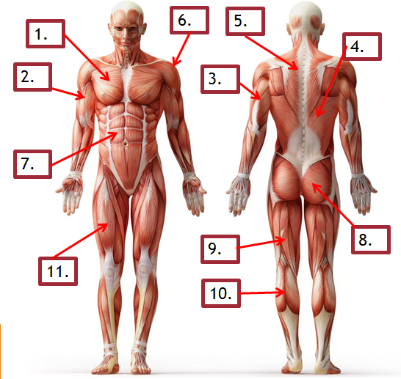

1.
2.
3.
4.
5.
6.
7.
8.
9.
10.
11.

B1 – Musculoskeletal system

Location of major bones
1
2
3
4
5
6
7
8
9
10

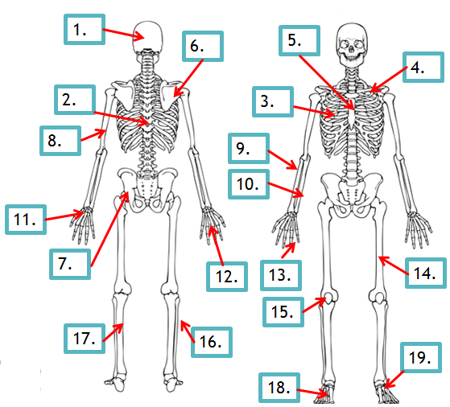
11
12
13
14
15
16
17
18
19

B.1 Musculoskeletal System

Structure and function of synovial joints
Structure of synovial Joints

Structure | Function
Cartilage
Ligament
Tendon

Hip – Label the parts of the joint to include, bones, muscles, cartilage, ligament and tendon

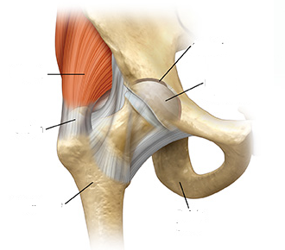

Shoulder - Label the parts of the joint to include, bones, muscles, cartilage, ligament and tendon

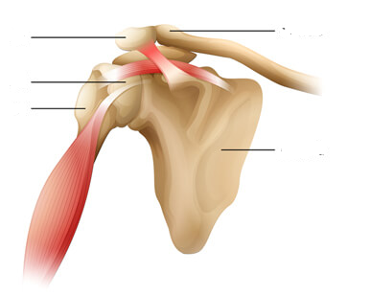

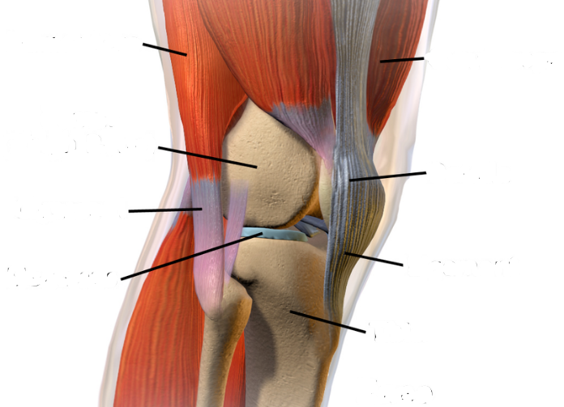
Knee- Label the parts of the joint to include, bones, muscles, cartilage, ligament and tendon

Elbow- Label the parts of the joint to include, bones, muscles, cartilage, ligament and tendon
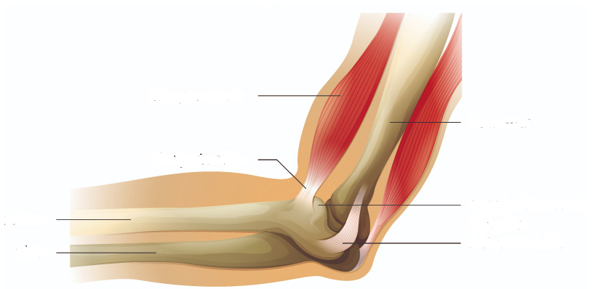

B.1 Musculoskeletal system

What are the short term effects of training on the muscular skeletal system
Muscular System – How progressive overload encourages micro muscle tears
1
2
3
Skeletal System – The effect of a warm up and flexibility exercises on joints
1
2
4
B.2 – Cardiorespiratory system

Structures of the cardiovascular system – The heart
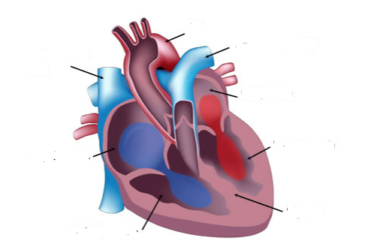

B.2 – Cardiorespiratory system

Structures of the respiratory system
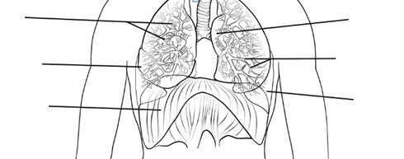

Describe the role of the:

Bronchi

Bronchioles

Alveoli

B.2 Cardiorespiratory System

What are the short term effects of training on the cardiorespiratory system
Cardiovascular System – What changes happen to the cardiovascular system when we start to exercise?
1
2
3
Respiratory System – What changes happen to the respiratory system when we start to exercise?
1
2
4

Learning Aim C Implement a self-designed personal fitness training programme - C.1/2 Safely implement a personal fitness training programme
 | Warm-up | Training Session | Intensity | Cool-down | Health and Safety
Monday
Tuesday
Wednesday
Thursday
Friday
Saturday
Sunday

C.1/2 Training Diary for Week 1/6

Aims for the week
(What do you want to achieve this week in terms training? Train 3 times, Run 5km, improve recovery rates etc…)
Session Outcomes
What are your targets for the Circuit Training session? Work for the full amount of time at each station, X number of reps etc…)
How my training week went and notes for next week:

Please add some photos as evidence of practical sessions (copy and paste your photos into the space below (minimum of four).

C.1/2 Programme Design (Week 2/6) (Minimum of 3 extra sessions a week)
 | Warm-up | Training Session | Intensity | Cool-down | Health and Safety
Monday
Tuesday
Wednesday
Thursday
Friday
Saturday
Sunday

C.1/2 Training Diary for Week 2/6

Aims for the week
(What do you want to achieve this week in terms training? Train 3 times, Run 5km, improve recovery rates etc…)
Session Outcomes
What are your targets for the Circuit Training session? Work for the full amount of time at each station, X number of reps etc…)
How my training week went and notes for next week:

Please add some photos as evidence of practical sessions (copy and paste your photos into the space below (minimum of four).

C.1/2 Programme Design (Week 3/6) (Minimum of 3 extra sessions a week)
 | Warm-up | Training Session | Intensity | Cool-down | Health and Safety
Monday
Tuesday
Wednesday
Thursday
Friday
Saturday
Sunday

C.1/2 Training Diary for Week 3/6

Aims for the week
(What do you want to achieve this week in terms training? Train 3 times, Run 5km, improve recovery rates etc…)
Session Outcomes
What are your targets for the Circuit Training session? Work for the full amount of time at each station, X number of reps etc…)
How my training week went and notes for next week:

Please add some photos as evidence of practical sessions (copy and paste your photos into the space below (minimum of four).
C.1/2 Programme Design (Week 4/6) (Minimum of 3 extra sessions a week)
 | Warm-up | Training Session | Intensity | Cool-down | Health and Safety
Monday
Tuesday
Wednesday
Thursday
Friday
Saturday
Sunday

C.1/2 - Training Diary for Week 4/6

Aims for the week
(What do you want to achieve this week in terms training? Train 3 times, Run 5km, improve recovery rates etc…)
Session Outcomes
What are your targets for the Circuit Training session? Work for the full amount of time at each station, X number of reps etc…)
How my training week went and notes for next week:

Please add some photos as evidence of practical sessions (copy and paste your photos into the space below (minimum of four).

C.1/2 Programme Design (Week 5/6) (Minimum of 3 extra sessions a week)
 | Warm-up | Training Session | Intensity | Cool-down | Health and Safety
Monday
Tuesday
Wednesday
Thursday
Friday
Saturday
Sunday

C.1/2 - Training Diary for Week 5/6

Aims for the week
(What do you want to achieve this week in terms training? Train 3 times, Run 5km, improve recovery rates etc…)
Session Outcomes
What are your targets for the Circuit Training session? Work for the full amount of time at each station, X number of reps etc…)
How my training week went and notes for next week:

Please add some photos as evidence of practical sessions (copy and paste your photos into the space below (minimum of four).

C.1/2 Programme Design (Week 6/6) (Minimum of 3 extra sessions a week)
 | Warm-up | Training Session | Intensity | Cool-down | Health and Safety
Monday
Tuesday
Wednesday
Thursday
Friday
Saturday
Sunday

C.1/2 - Training Diary for Week 6/6

Aims for the week
(What do you want to achieve this week in terms training? Train 3 times, Run 5km, improve recovery rates etc…)
Session Outcomes
What are your targets for the Circuit Training session? Work for the full amount of time at each station, X number of reps etc…)
How my training week went and notes for next week:

Please add some photos as evidence of practical sessions (copy and paste your photos into the space below (minimum of four).

Learning Aim A.2:
P1 Know about exercise adherence factors and strategies for continued training success.

Choose four of the following exercise adherence factors and describe how they will have an impact on your training;
Access to facilities, Motivation and Commitment, Cost, Time, Emotional Barriers and Personal Injury.

Choose four of the following strategies for training success and describe how they will have an impact on your training; Setting SMARTER targets, Taking part in enjoyable activities, Support and reinforcement, Rewards for achieving goals and knowing about the benefits of a personal fitness training programme.
(Describe 4 personal adherence factors and 4 strategies for training success)

Unit 3 Topic D.1
Level 1 – Review the four week personal fitness training programme, identifying strengths and areas for improvement.

Level 2 Pass – Review the six week personal fitness training programme, describing strengths and areas for improvement.

Level 2 Merit – Explain strengths of the training programme and areas for improvement, providing recommendations for future training and performance.

Level 2 Distinction – Justify recommendations for future training and performance.

(M4/D3) P5 Reviewing my training programme

The strengths of my personal fitness training programme were:
The areas of my personal fitness training programme that could be improved are:
Explain and Justify the recommendations would you give for future training and performance.

