Calculating using W = mg
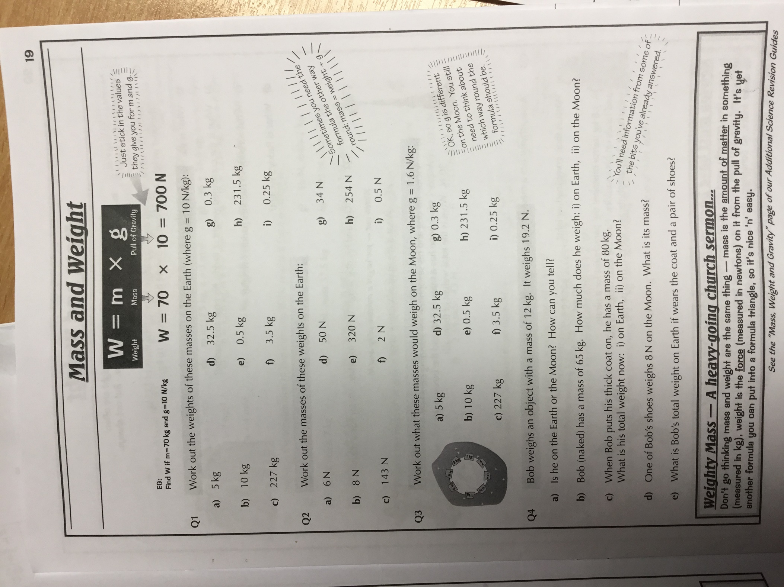

Work done video questions
- When is work done?
- What does mechanical work involve?
- What does electrical work involve?
- Which force acts between the sledge and the ground? Which energy transfer does this cause to occur?
- Write the equation used to calculate work done, including units.
- Explain how a car transfers energy when the brakes are applied.
- Pause the video when told to and calculate the answer. Then unpause and check!

Calculating using W = fd
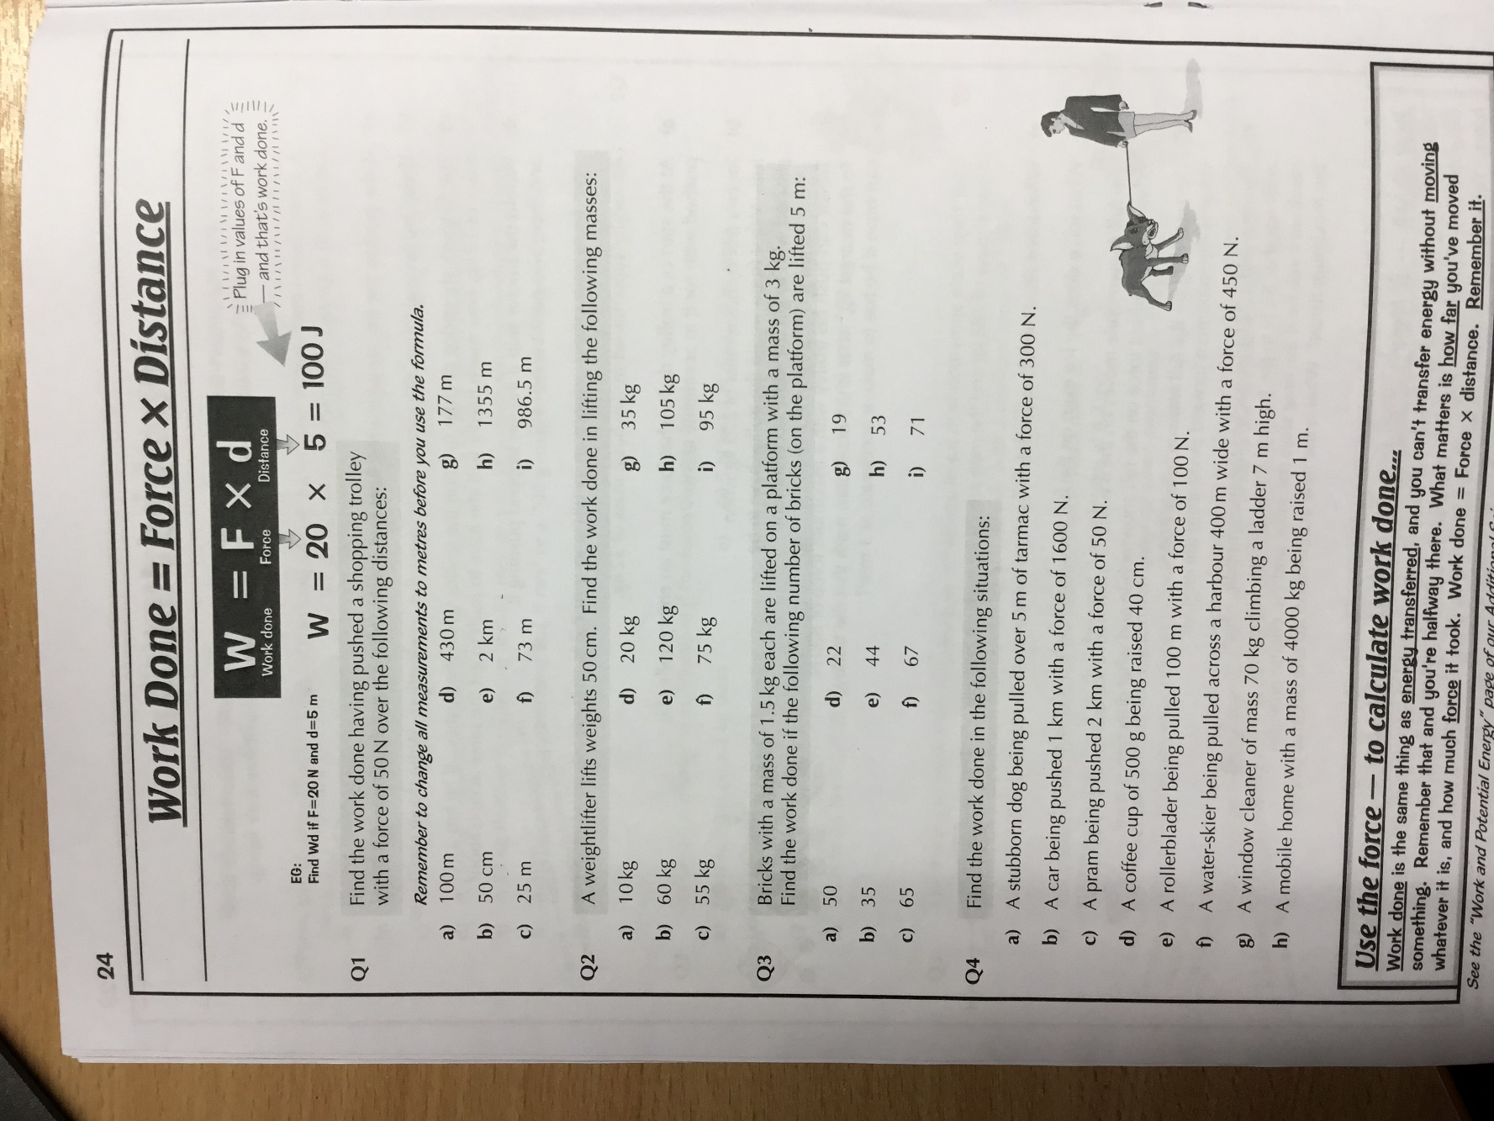
Challenge questions!
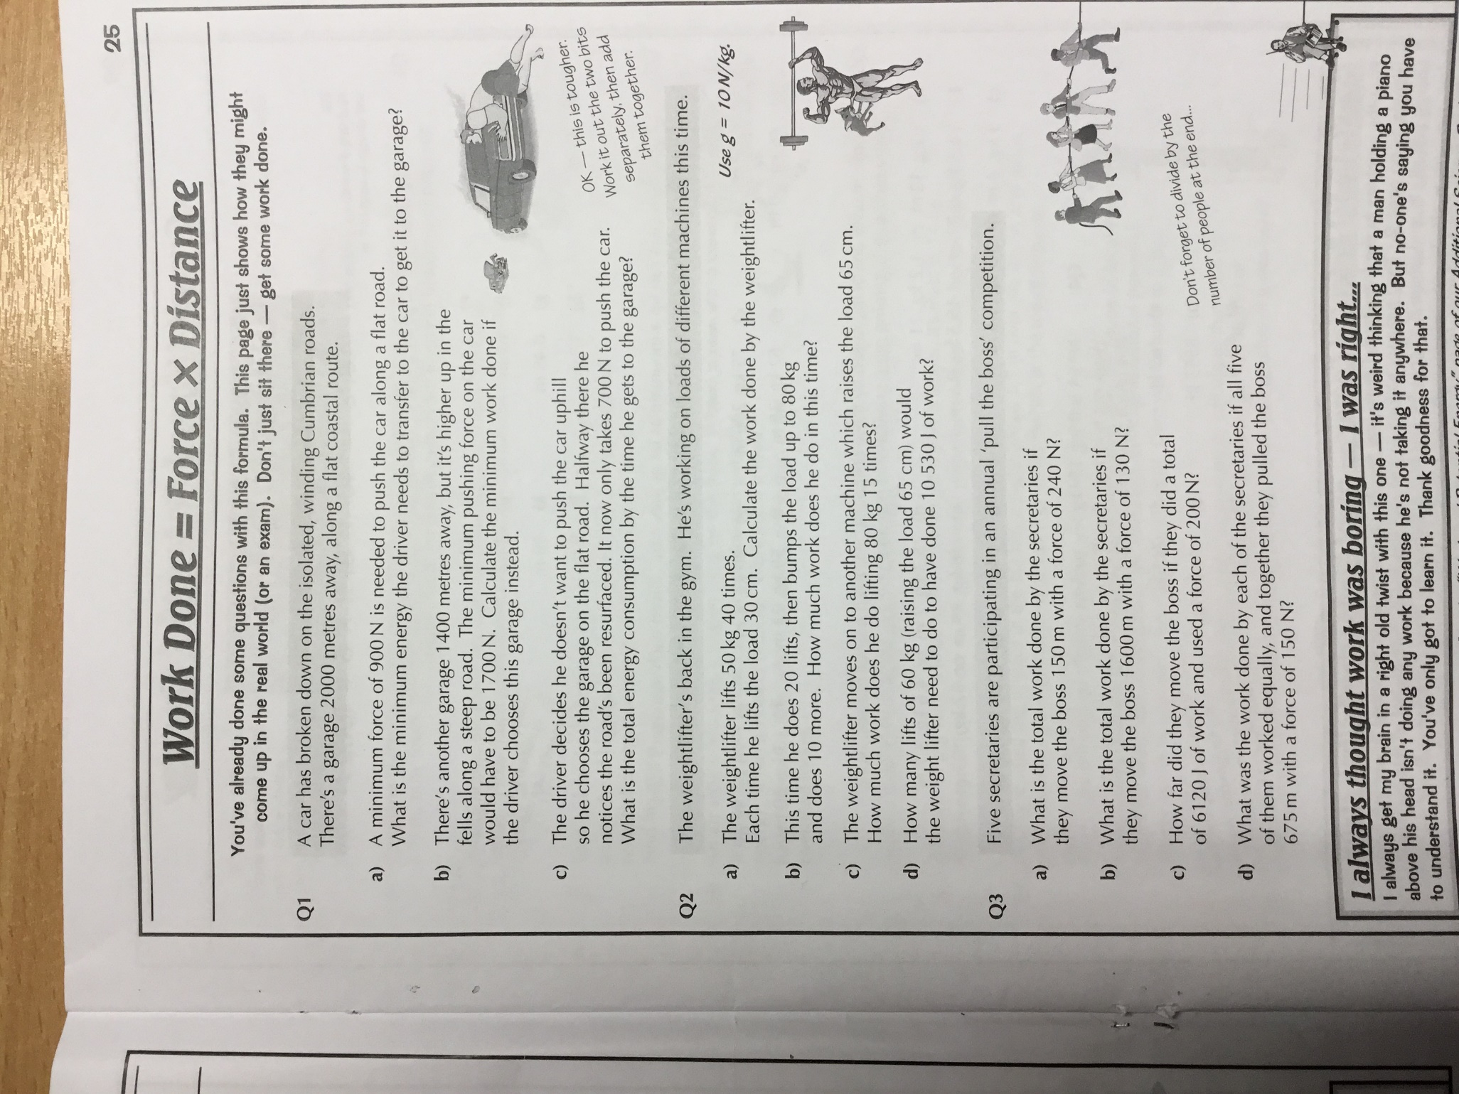

Work done comprehension task
Work is done when objects are displaced (moved) by a force. When work is done to overcome friction, thermal energy is transferred as a result. You can observe this by rubbing your hands together; your muscles are doing work to overcome the friction between your hands. Your hands become hot as a result of this.
Another example is when meteorites enter the Earth’s atmosphere from space. Meteroites are small objects from space. As they pass through the atmosphere, friction is caused by the air resistance. This results in thermal energy being transferred, sometimes so much so that the meteorite will glow and become visible as a ‘shooting star’.
Work done is measured in Joules as it is equal to the amount of energy transferred. One joule of work is done when a force of one newton causes a displacement of one metre. 1 joule = 1 newton-metre.

- What does ‘displaced’ mean?
- Explain why meteorites can sometimes be seen as shooting stars.
- How many joules of work is done if an object is displace by 2 metres by a force of 2 newtons?
- How many newton metres are in:
- 30 joules?
- 55 J?
- 2.75 joules?

Forces and elasticity – comprehension task
When a force acts on an object, the object may change shape by bending, stretching or compressing - or a combination of all three shape changes. However, there must be more than one force acting to change the shape of a stationary object in the following ways:
Bend an object's ends past each other, eg when an archer pulls an arrow back against a bow.
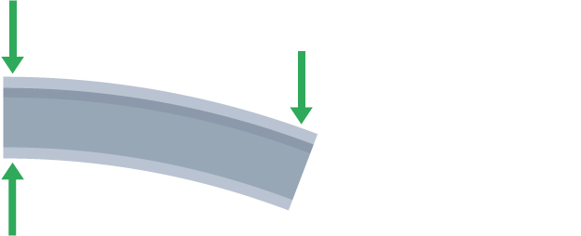
Pull an object's ends apart, eg when a rubber band is stretched.
Push an object's ends together, eg when an empty drinks can is squashed.
A change in shape is called deformation:
- elastic deformation is reversed when the force is removed
- inelastic deformation is not fully reversed when the force is removed - there is a permanent change in shape
A rubber band undergoes elastic deformation when stretched a little. A metal drinks can undergoes inelastic deformation when it is squashed.
Questions:
- How might an elastic object change when a force is exerted upon it?
- What is meant by ‘deformation’?
- Explain the difference between elastic and inelastic deformation.
- Explain why the rubber band would need two forces acting in opposite directions acting upon it in order to stretch? Why would it not work with just one force in one direction?

Calculating elastic potential energy
Spring constant (N/m) | Extension (m) | Working  E_{e} = 0.5 x k x e² | Elastic potential energy (J)
30 | 0.3
200 | 4
1 | 0.04
17 | 22
55 | 5
5.9 | 1
77 | 0.4
1500 | 0.09
150 | 0.9

Challenge:
Sometimes you will need to convert some units before you input the numbers into the equation. So, if you have an extension in cm, you need to divide by 100 first to get it into m.
Extension | Extension (m) | Spring constant (N/m) | Working  E_{e} = 0.5 x k x e² | Elastic potential energy (J)
5000cm |  | 40
350cm |  | 55
50cm |  | 500
210cm |  | 15
65cm |  | 30
29cm |  | 110
7700cm |  | 35
800cm |  | 9
1200cm |  | 10

Hooke’s Law video questions
- What happens when a force is exerted on a spring?
- How do you calculate the extension of a spring when a force is added to it?
- What does Hooke’s law state?
- What is meant by elastic limit/limit of proportionality?
- What does the gradient look like on a graph is the force and extension are directly proportional to one another? You can sketch it is you like.
- Give an example of an object that does not obey Hooke’s law.
- From a graph, how would you know an elastic object has exceeded its elastic limit/limit of proportionality?
- Which letter is used to represent spring constant?
- State the equation used to calculate elastic potential energy.

6 mark question – Investigating Hooke’s Law’
A student has the following equipment:
- A spring
- A clamp and boss stand
- Two rulers
- Some masses and a mass hanger
Explain how they could use this equipment to investigate the spring constant of the spring.

PLANNING YOUR ANSWER

Key words (2 minutes) Diagram (2 minutes)

Sentences – put your keywords into sentences, they Write your full answer here (6 minutes)
don’t have to be in order, just in sentences!
4 minutes

HOMEWORK QUESTIONS
Q1.
A student carried out an investigation to determine the spring constant of a spring.
The table below gives the data obtained by the student.

Force in N | Extension in cm
0 | 0.0
2 | 3.5
4 | 8.0
6 | 12.5
8 | 16.0
10 | 20.0
(a) Describe a method the student could have used to obtain the data given in the table above.
Your answer should include any cause of inaccuracy in the data.
Your answer may include a labelled diagram.
.........
(6)
(b) The student measured the extension for five different forces rather than just measuring the extension for one force.
Suggest why.
___________________________________________________________________
___________________________________________________________________
(1)
The diagram below shows some of the data obtained by the student.
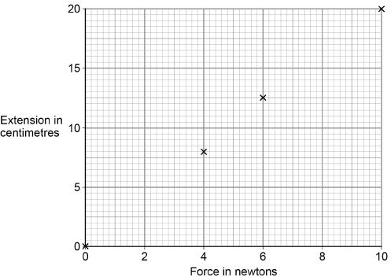

(c) Complete the diagram above by plotting the missing data from the table above.
Draw the line of best fit.
The table above is repeated here to help you answer this question.

Force in N | Extension in cm
0 | 0.0
2 | 3.5
4 | 8.0
6 | 12.5
8 | 16.0
10 | 20.0
(2)
(d) Write down the equation that links extension, force and spring constant.
___________________________________________________________________
(1)
(e) Calculate the spring constant of the spring that the student used.
Give your answer in newtons per metre.
___________________________________________________________________
___________________________________________________________________
___________________________________________________________________
___________________________________________________________________
Spring constant = ______________________ N/m
(4)
(f) Hooke’s Law states that:
‘The extension of an elastic object is directly proportional to the force applied, provided the limit of proportionality is not exceeded.’
The student concluded that over the range of force used, the spring obeyed Hooke’s Law.
Explain how the data supports the student’s conclusion.
___________________________________________________________________
___________________________________________________________________
___________________________________________________________________
___________________________________________________________________
(2)
(Total 16 marks)
Q2.
A student investigated how the extension of a spring depends on the force applied to the spring.
The diagram shows the spring before and after a force had been applied.
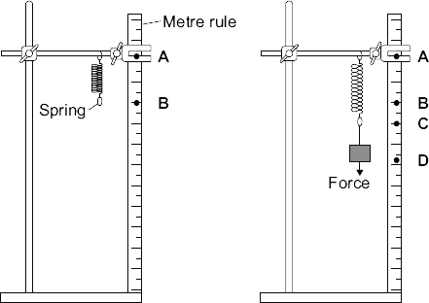
(a) (i) Complete the following sentence using letters, A, B, C or D, from the diagram.
The extension of the spring is the distance between the positions labelled
___________and ___________ on the metre rule.
(1)
(ii) What form of energy is stored in the stretched spring?
______________________________________________________________
(1)
(b) The results from the investigation are plotted on the following graph.
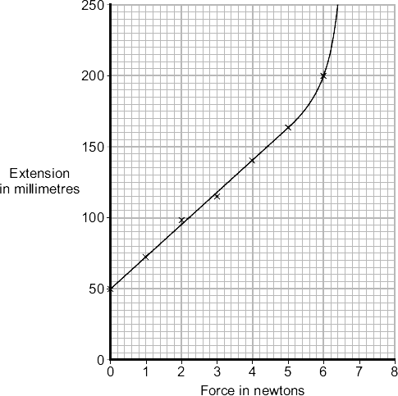
(i) The graph shows that the student has made an error throughout the investigation.
What error has the student made?
______________________________________________________________
______________________________________________________________
Give the reason for your answer.
______________________________________________________________
______________________________________________________________
(2)
(ii) The student has loaded the spring beyond its limit of proportionality.
Mark on the graph line the limit of proportionality of the spring. Label the point P.
Give the reason for choosing your point P. (2)

(c) The student uses a different spring as a spring balance. When the student hangs a stone from this spring, its extension is 72 mm.
The spring does not go past the limit of proportionality.
Calculate the force exerted by the stone on the spring.

spring constant = 25 N/m
Show clearly how you work out your answer.
___________________________________________________________________
___________________________________________________________________
Force = _________________________ N
(2)
(Total 8 marks)

Once you have completed these homework questions, please email cbuffham@bleucoatmeres.co.uk and I will reply with the mark scheme .

