Natural Resources
Match these keys words to the definitions
Non-renewable | Renewable | Sustainable
 | will not run out if it is looked after carefully
 | will not run out. Also called infinite (unlimited amount)
 | will eventually run out. Cannot be re-newed. Also called finite (limited)

Now decide which resources go in each category. You should check the fact sheet to get more information.
Wind power Nuclear power Hydroelectric Solar Coal Oil
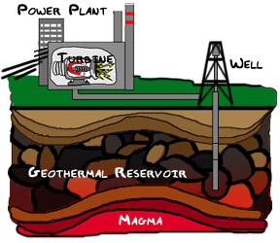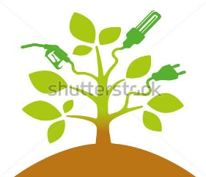
Gas Wave power Tidal power Geothermal power Biofuels wood

Non-renewable | Renewable | Sustainable

How is world energy consumption (use) changing?
You are going to produce a compound line graph. This is where each line is piled up on top of the last.
 | 1990 | 1995 | 2000 | 2005 | 2008 | 2010 | 2015
Coal | 2500 | 2600 | 2800 | 3300 | 3200 | 3500 | 4000
Renewables | 50 | 50 | 100 | 100 | 100 | 100 | 200
Hydro-electricity | 300 | 300 | 400 | 600 | 600 | 1200 | 1400
Nuclear energy | 200 | 300 | 300 | 500 | 500 | 600 | 600
Natural gas | 1900 | 2000 | 2900 | 2950 | 2900 | 3000 | 3200
Oil | 3000 | 3100 | 3500 | 3900 | 3600 | 4000 | 4100
year
Million tonnes of oil (equivalent)
13,500
13,000
12,000
11,500
11,000
Key
Coal
Renewables
Hydro
Nuclear
Natural Gas
Oil

10.500
10,000
9500
9000
8500
8000
7500
7000
6500
6000
5500
5000
4500
4000
3500
3000
2500
2000
1500
1000
500
0
 |  |  | 1990 |  | 1995 |  | 2000 |  | 2005 |  | 2010  2008 |  | 2015

