Student/parent guide to Microsoft Teams Class sites

There is no need to worry if you don’t own a PC or laptop in your household. If you own a mobile phone or gaming console you should be able to access Microsoft Teams. Please find below instructions for accessing Microsoft Teams from different devices.
PC/Laptop Pages 1- 4
iPad/iPhone Pages 5 - 6
Android tablet/Android phone Page 7
Kindle Page 7
Xbox One Page 8

Using a PC/Laptop

- We would advise that you do not use Internet Explorer or Edge browsers to access Google Classroom or Microsoft Team Sites.
Instead, check that you have Chrome browser installed on your machine – this will ensure that everything works effectively.

- Open the Chrome browser and type in the URL portal.office.com

- To sign onto Microsoft Teams Class site, please use the username and password provided below:
Username:
Password:
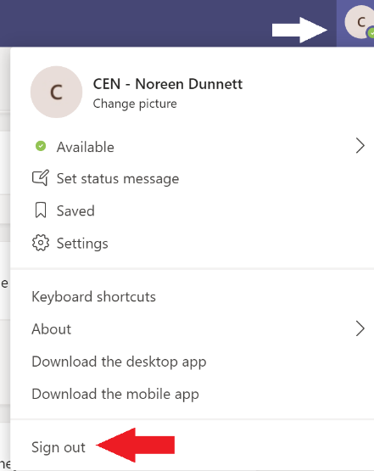
NB Please note that if you already have a Microsoft account (e.g for your Xbox One), you will automatically be signed in with that account rather than the new student one provided above. You will need to sign out of your existing account first. Tap your initial in top right of screen (see white arrow pointing at it), then Sign Out (red arrow). Close down Chrome and try logging in again to portal.office.com with the username and password above.

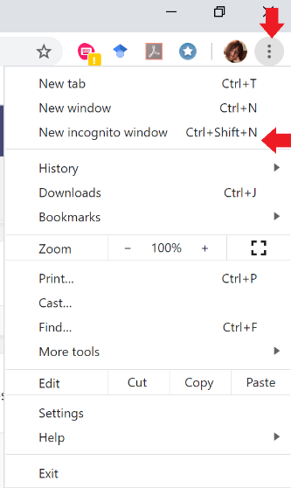
If that doesn’t work, open a new Incognito tab in Chrome 1. Click on the three dots at top right-hand corner of screen – see red arrow pointing down.
2. Then click on New Incognito tab (red arrow pointing to left)

Once the tab is open, type portal.office.com and follow the instructions for signing in below in 4.

- You will have to type in your username twice, firstly on the screen on left and then on the right-hand screen.
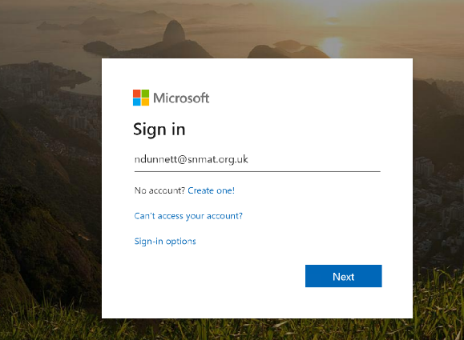

Finally you will be asked to type in the password provided on the previous
page, or by your class teacher.

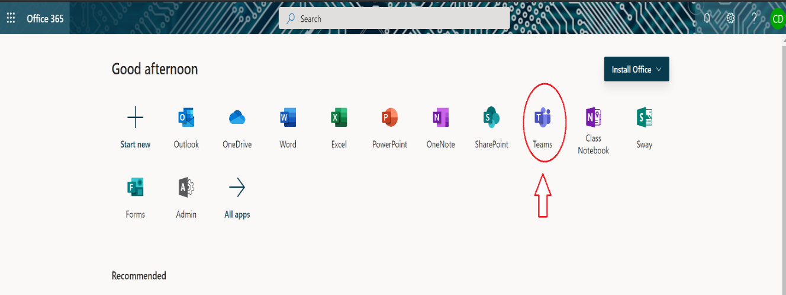
- Once you have signed into Microsoft Teams site successfully you will arrive at the Home screen for the site. Click on Teams (circled in red with arrow)

- When you have clicked on Teams you will see any Team Sites you may be a member of – for example you may see your own class (e.g Jaguars, Butterflies, Class 1 etc). Click on your class site.
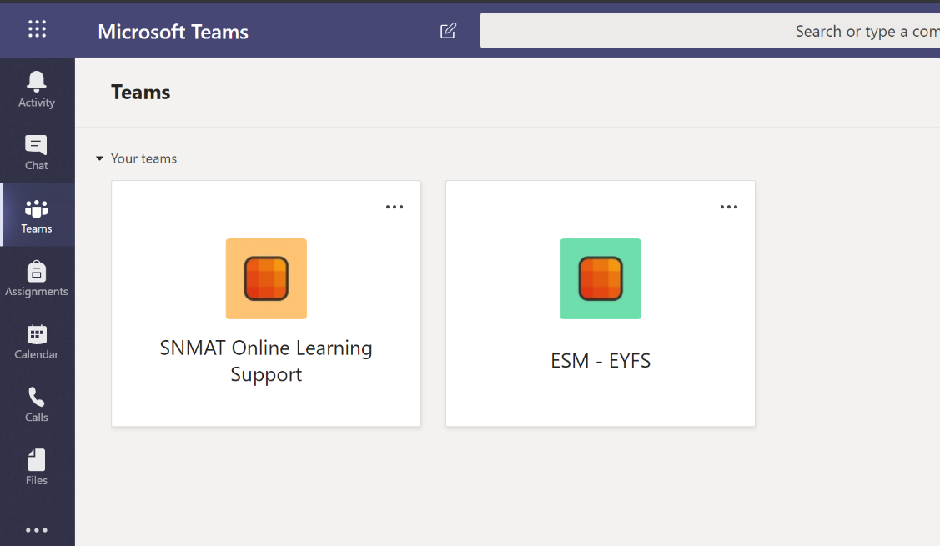

- The next screen you arrive on, you will notice there are several tabs at the top of the page – Posts, Files, Class Notebook, Assignments, Grades and +

You will land on the Posts tab (it’s got a line under it). On this page you can post messages to your teacher (or other students) and get replies from them, you can include pictures and video here too or attach files.

Remember that when you type in comments here in Posts you and your classmates will all be using the same account so your teacher won’t know who has posted. Remember to type your name first and then your message e.g Leah – I can’t find the document you posted Miss.

- Click on the Files tab. You will see a folder called Class Materials folder which your teacher will put documents in for you to work from. These documents cannot be edited, you can only read them.

- To create your own folder, click on down arrow next to New and select Folder, from the drop-down menu. A box will come up for you to create a name for your folder – name it with your own name.
You will notice that you can also create Word, Excel, Powerpoint files from this menu too. Make sure you create these files when you have clicked in your own folder in Files.
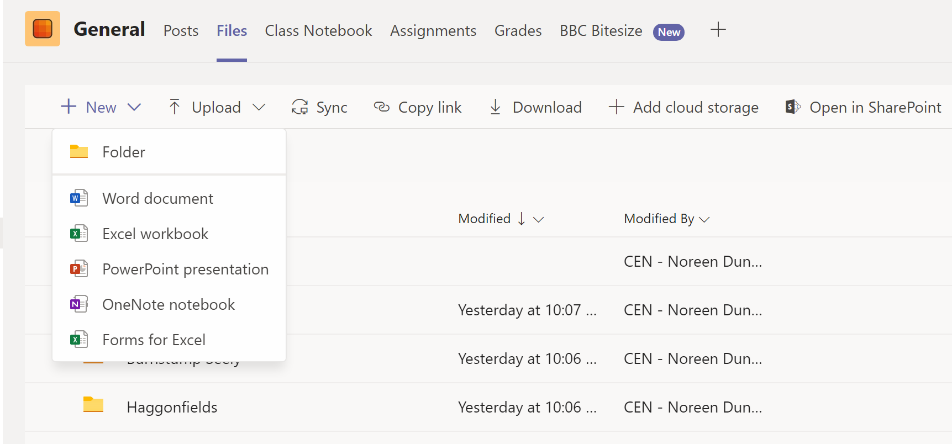

- You may find that your teacher has created other tabs along the top alongside Posts, Files, Class Notebook, Assignments, Grades. You may have some tabs to other websites your teacher wants you to use, such as BBC Bitesize or My Maths.

- You can now start posting messages to your teacher and classmates in the Posts tab, if you need help or support.

Using an iPad or iPhone to access Microsoft Teams

- To use Microsoft Teams on an iPad or iPhone you will need to install the Microsoft Teams app from the App Store. Type Microsoft Teams into the Search, find Microsoft Teams (see below) and tap on Get.
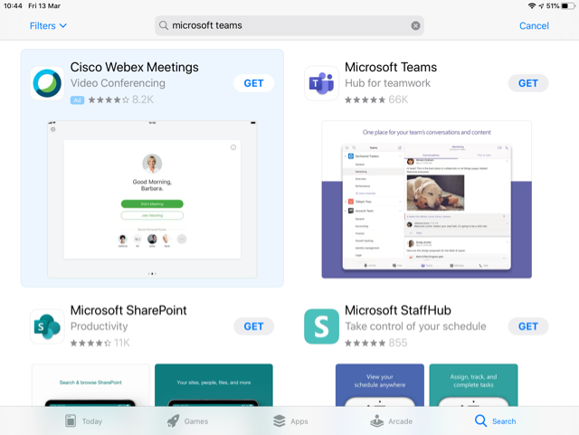

- Once the app is installed on your iPhone or iPad, to sign into Microsoft Teams, please use the username and password provided below:
Username:
Password:

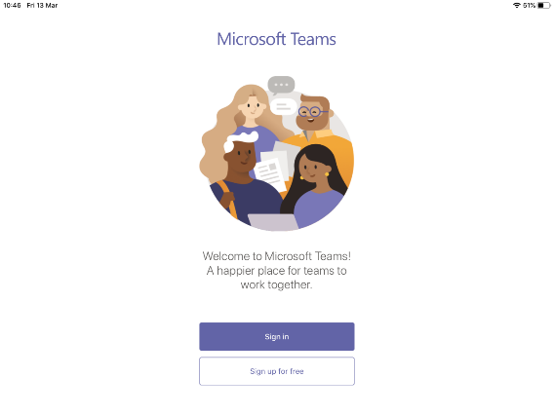

Finally you will be asked to input the password provided above in 2.

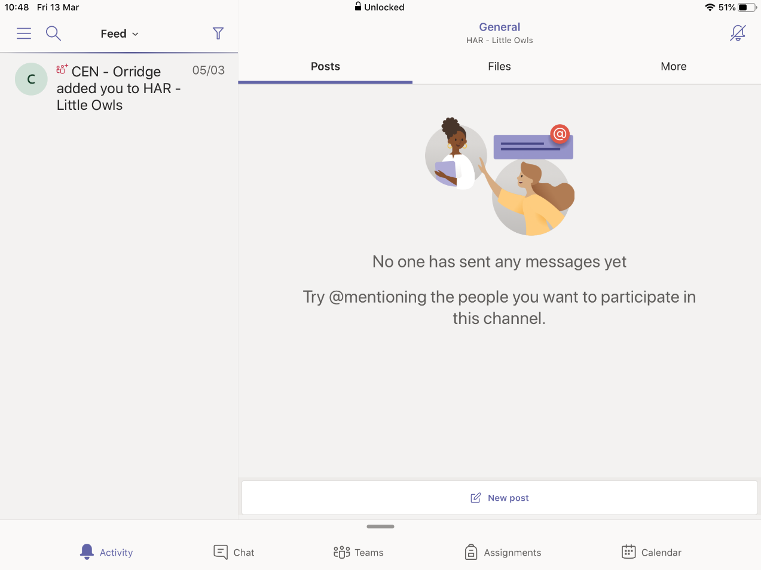
- You will arrive on this screen:

- You will notice that there is a menu bar at the bottom of the page with various options. You automatically land on Activity, which shows any comments posted or files uploaded. To join in the conversation with the teacher and other students, tap on Teams.

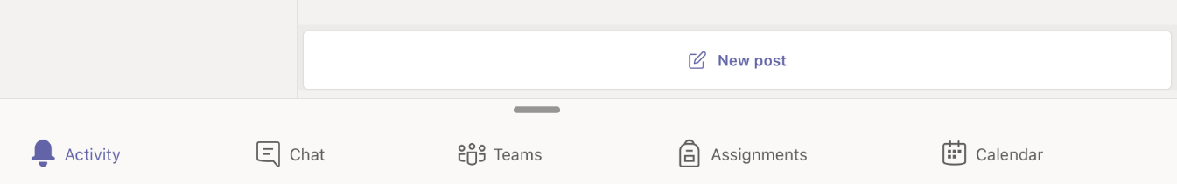

- To find documents which the teacher has posted here for you to work on, see the tabs at the top of the home screen – tap on Files.

You should see a folder where your teacher has placed documents. Tap to open it. These documents are READ-ONLY – you cannot edit them.
- IMPORTANT – as your whole class is logging into this Microsoft Teams site as if they were the same person, your teacher won’t know who he/she is talking to so if you are posting a comment in the Teams tab please put your name or initial first e.g
Jamie – Please Miss can I ask a question about……..

Using an Android phone/tablet to access Microsoft Teams

- To use Microsoft Teams on an Android phone or tablet you will need to install the Microsoft Teams app from the Google Play Store. Type Microsoft Teams into the Search bar, find Microsoft Teams (see below) and tap on Install.
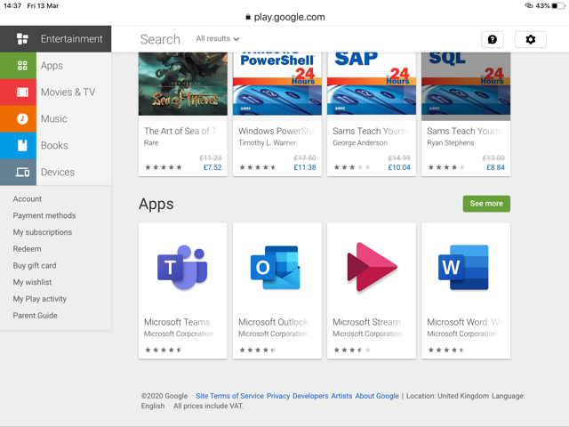

- Follow the instructions for signing in in the previous section for using an iPad or iPhone.

Using a Kindle Fire to access Microsoft Teams

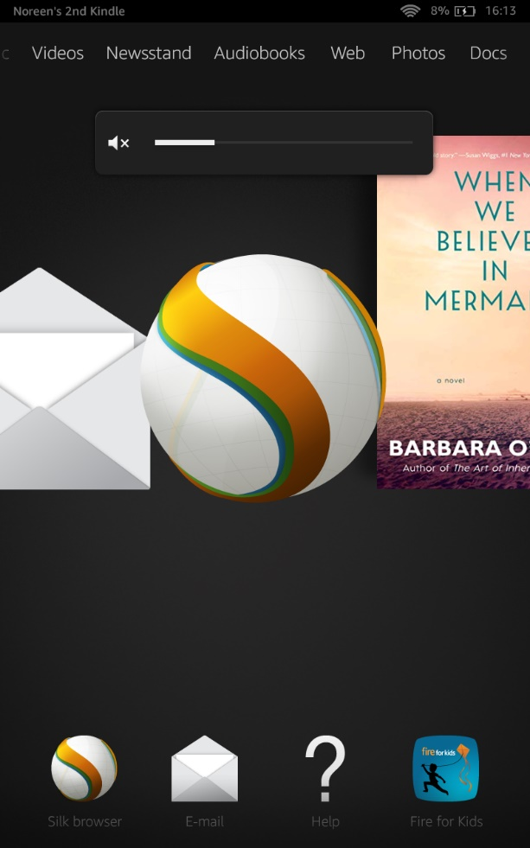
- Since Kindle devices have no access to the Google Play store sadly there is no app you can install for Microsoft Teams. However, you can access Microsoft Teams in the same way as on a PC/Laptop, via a web browser.
The web browser on the Kindle is Silk.

It looks like this:

Tap on the icon to open the browser.

- Once the browser is open, type http://portal.office.com

- Now follow the instructions on pages 1 – 4 of this document, to sign into the Microsoft Teams

Using a gaming console – Xbox One – to access Microsoft Teams

- Most gaming consoles have access to an Internet browser such as Internet Explorer. The instructions below are for Xbox One but should be applicable to other gaming consoles such as PS4 (Open the browser by tapping the X button on your PS4 controller.)

- Locate the Microsoft Edge app on the Home page – see below
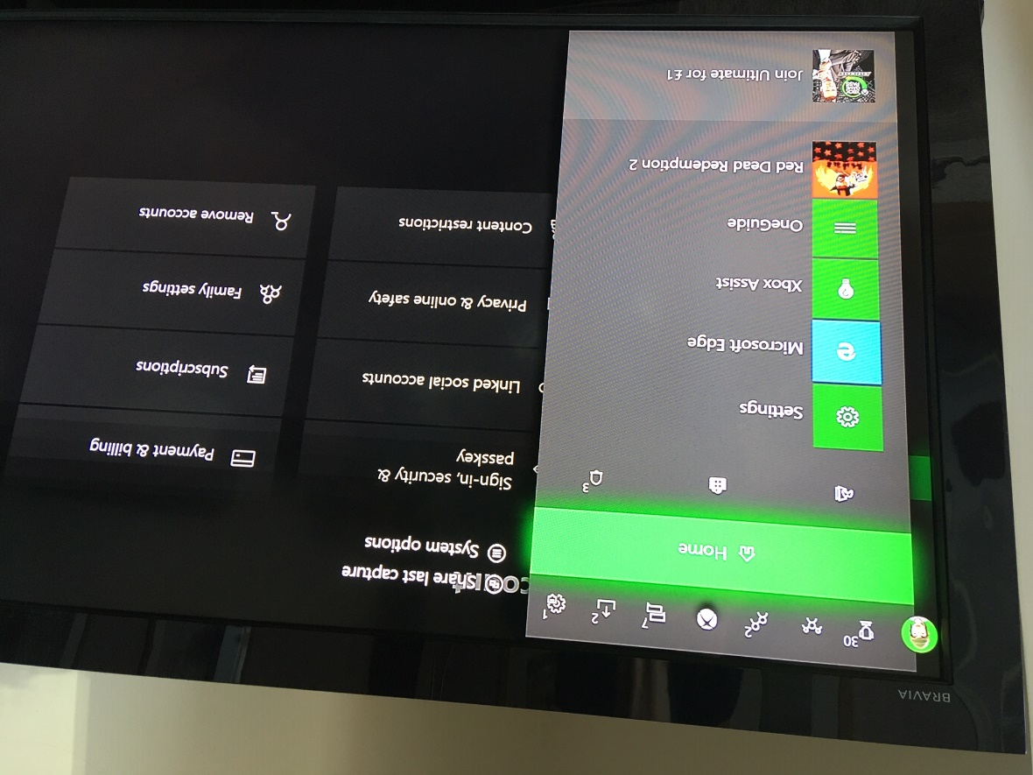

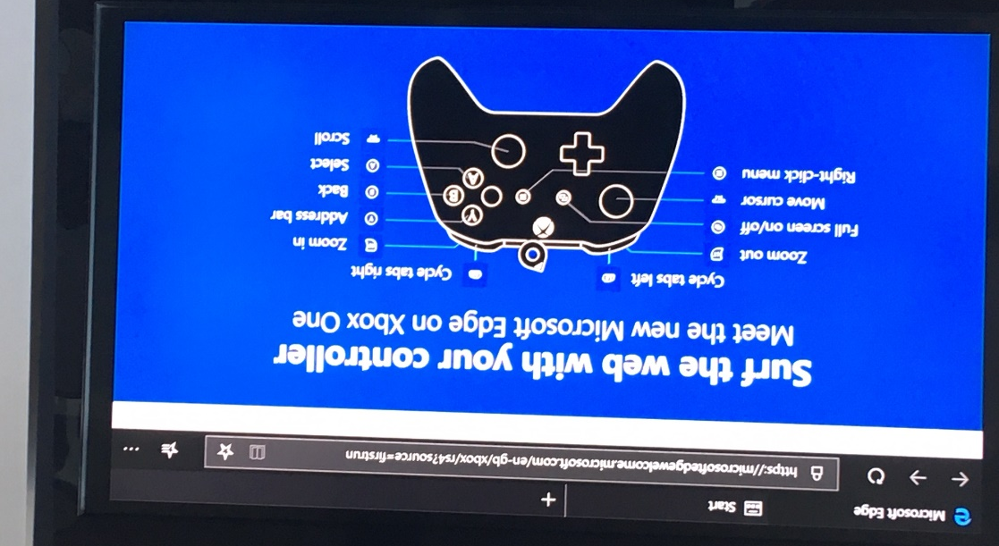
- Open Microsoft Edge and type http://portal.office.com into the address bar. You should see the screen below which gives instructions on how to use the game controller with the browser.

- Follow the instructions for PC/Laptop on pages 1-4

