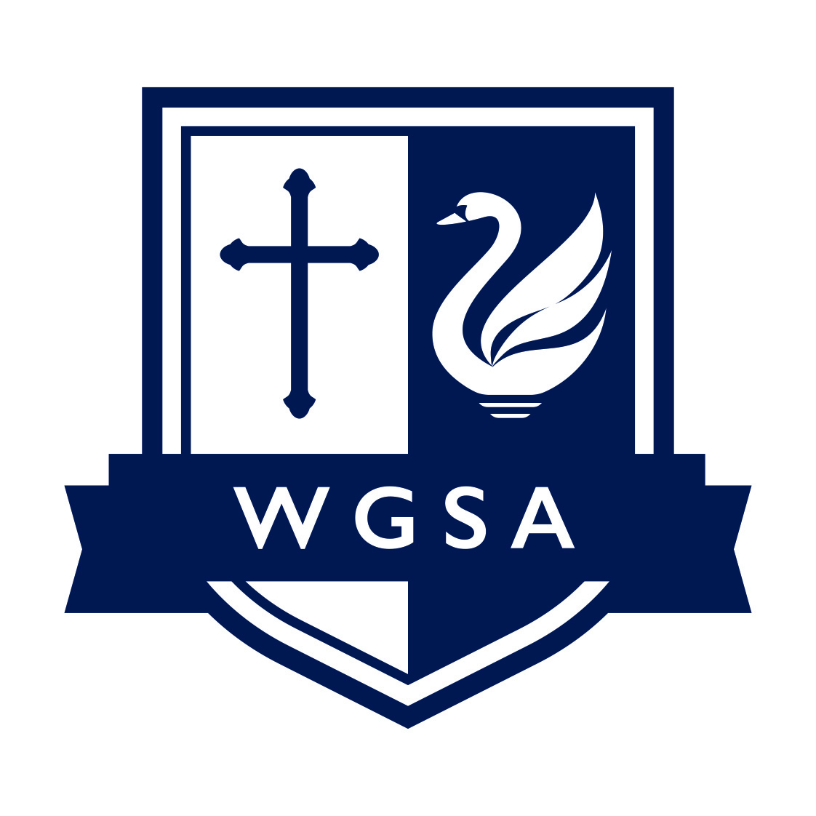

UNIFORM LIST AND EXPECTATIONS
Information for Parents

Decisions on uniform are the responsibility of the Executive Principal, and their decision is final. Students not wearing the full Academy uniform will be isolated until the matter is resolved. Blazers must be worn at all times.

Hair
Hair accessories should be plain black, grey, or navy blue (no bandanas, large head bands or coloured accessories are allowed). Excessive hair styles are strongly discouraged, and non-natural or multiple hair colours are not allowed. Patterns shaved into hair are not permitted.

Accessories
No make-up, jewelry, artificial nails, colored nail varnish, false eyelashes, body piercings, fashion badges/bracelets are allowed. Any ‘ear-piercing’ must be done in the long summer holiday as no ear jewelry can be worn in the academy. Inexpensive watches are acceptable but watches, such as the Apple Watch etc, which can carry data and allow communication are not permitted under any circumstance in line with our policy on electronic devices.

Valuables and mobile phones
Electrical items/valuables are not allowed on the academy site. Mobile phones can be brought into the academy at the student’s risk but must be switched off before entering the premises and placed inside the student’s bag. There are a number of sanctions given where the rules on electronic devices are not followed. The academy takes no responsibility for lost, stolen or damaged electronic devices as they are not permitted on site.

PE Uniform
The PE Department maintains the academy’s high standards of uniform at all times. Therefore, students are required to bring compulsory kit items to ALL of their Physical Education lessons.

In PE we feel that the high standard of dress impacts on the working and motivational ethos of the students. All students are expected to bring appropriate kit to all PE lessons. Pupils who fail to bring appropriate PE kit will be provided with clean garments to ensure full participation in the lesson.

Uniform purchasing options
All items marked * can only be purchased via our uniform supplier, Uniform Direct.

You can purchase compulsory and optional uniform items from Uniform Direct online via our website and instore at Downtown Stores, Gonerby Moor, Grantham NG32 2AB.

Until the Autumn Term 2025, ties can only be purchased directly from the academy via your MCAS account.

All other uniform items can be purchased from local supermarkets and retailers.

GIRLS UNIFORM LIST | BOYS UNIFORM LIST
Navy girl’s blazer with pale blue trim on lapel and academy logo | Navy boy’s blazer with pale blue trim on lapel and academy logo*
Light blue long/short sleeve formal blouse/ shirt (not fitted and with top button done up) | Light blue long/short sleeve formal shirt (with top button done up)
Navy academy tie (clip on)* | Navy academy tie (clip on)*
Mid-grey pleated skirt, knee length or plain, mid-grey cotton formal tailored school trousers (not leggings or trousers made from denim, canvas or lycra) | Plain mid-grey formal trousers (no jeans allowed)
Plain grey or black tights or plain ankle/knee socks may be worn | Plain socks
Plain grey v-neck knitwear (optional) | Plain grey v-neck knitwear (optional)
Plain black formal shoes (no heels, boots, plimsolls, or trainers) | Plain black formal shoes (no boots, plimsolls or trainers allowed)
A formal outdoor coat (no hoodies, tracksuit tops, denim jackets allowed) | A formal outdoor coat (no hoodies, tracksuit tops, denim jackets allowed)
GIRLS PE UNIFORM | BOYS PE UNIFORM
Navy sports top with academy logo* | Navy sports top with academy logo*
Navy skort/shorts* | Navy sports shorts*
Sports socks navy | Sports socks navy
Sports trainers | Sports trainers
Navy outdoor sports top (optional) | Navy outdoor sports top (optional)
Navy training parts/leggings (optional) | Navy training parts (optional)

